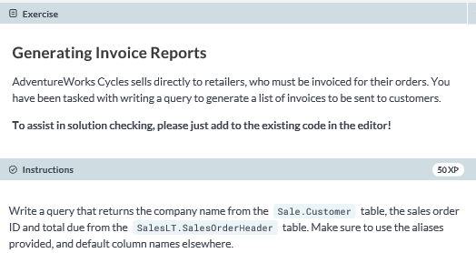

**-- select the CompanyName, SalesOrderId, and TotalDue columns from the appropriate tables**

**SELECT CompanyName, SalesOrderId,TotalDue**

**FROM SalesLT.Customer AS c**

**JOIN SalesLT.SalesOrderHeader AS oh**

**-- join tables based on CustomerID**

**ON c.CustomerID = oh.CustomerID;**

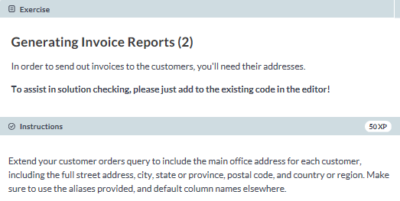

**SELECT c.CompanyName, a.AddressLine1, ISNULL(a.AddressLine2, '') AS AddressLine2, a.City, a.StateProvince, a.PostalCode, a.CountryRegion, oh.SalesOrderID, oh.TotalDue**

**FROM SalesLT.Customer AS c**

**-- join the SalesOrderHeader table**

**JOIN SalesLT.SalesOrderHeader AS oh**

**ON oh.CustomerID = c.CustomerID**

**-- join the CustomerAddress table**

**JOIN SalesLT.CustomerAddress AS ca**

**-- filter for where the AddressType is 'Main Office'**

**ON c.CustomerID = ca.CustomerID AND AddressType = 'Main Office'**

**JOIN SalesLT.Address AS a**

**ON ca.AddressID = a.AddressID;**

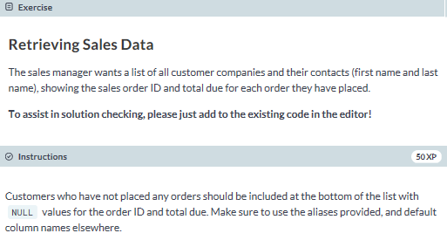

**-- select the CompanyName, FirstName, LastName, SalesOrderID and TotalDue columns**

**-- from the appropriate tables**

**SELECT c.CompanyName, c.FirstName, c.LastName, oh.SalesOrderID, oh.TotalDue**

**FROM SalesLT.Customer AS c**

**LEFT JOIN SalesLT.SalesOrderHeader AS oh**

**-- join based on CustomerID**

**ON c.CustomerID = oh.CustomerID**

**-- order the SalesOrderIDs from highest to lowest**

**ORDER BY oh.SalesOrderID DESC;**

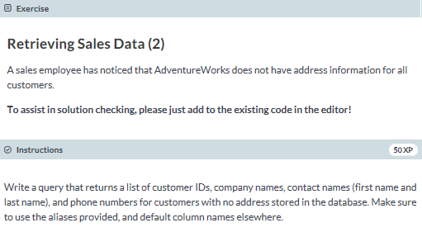

**SELECT c.CompanyName, c.FirstName, c.LastName, c.Phone**

**FROM SalesLT.Customer AS c**

**LEFT JOIN SalesLT.CustomerAddress AS ca**

**-- join based on CustomerID**

**ON c.CustomerID = ca.CustomerID**

**-- filter for when the AddressID doesn't exist**

**WHERE ca.AddressID IS NULL;**

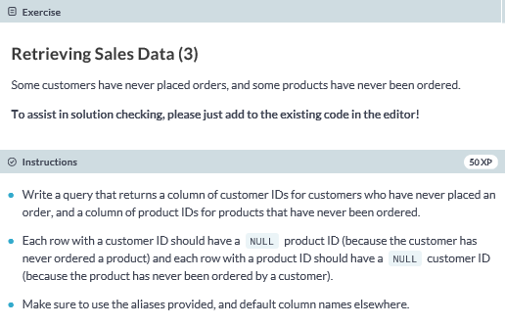

**SELECT c.CustomerID, p.ProductID**

**FROM SalesLT.Customer AS c**

**FULL JOIN SalesLT.SalesOrderHeader AS oh**

**ON c.CustomerID = oh.CustomerID**

**FULL JOIN SalesLT.SalesOrderDetail AS od**

**-- join based on the SalesOrderID**

**ON od.SalesOrderID = oh.SalesOrderID**

**FULL JOIN SalesLT.Product AS p**

**-- join based on the ProductID**

**ON p.ProductID = od.ProductID**

**-- filter for nonexistent SalesOrderIDs**

**WHERE oh.SalesOrderID IS NULL**

**ORDER BY ProductID, CustomerID;**